**Exercise E.3-1: Hardware Trigger Scanning**

Slide 139

This exercise shows how to connect signals through a switch module to the analog input of a DAQ device. There are numerous ways to tell the switch when to advance: send a software trigger using the Send SW Trig VI, connect to the Switch Advance terminal on the switch terminal block, connect to the AUX connector (available on some switches and DMMs) using an AUX-AUX cable, use TTL lines on the backplane, etc. In this exercise we will program the switch to advance the user-defined scan list each time the Digital Trigger button on the DAQ Accessory is pressed. The main take away from this exercise is how to set up a switch with an external hardware trigger using NI-SWITCH.

This exercise requires the following equipment:

* PXI Chassis
* PXI-6040e DAQ
* PXI-2503 Switch
* DAQ Signal Accessory
* SH68-68 Cable
* DMM/Switch Accessory (The DMM/Switch Accessory is a custom terminal block designed for demonstrating the speed and accuracy of National Instruments digital multimeters (DMMs) and NI PXI-2501 or NI PXI-2503 switches. You can route and measure the internal signals on the accessory with National Instruments DMMs and switch modules.)
* Three 5” wires (wires shorter than this will prevent the DMM/Switch Accessory from plugging into the 2503)

1. Insert the PXI-6040e DAQ card and the PXI-2503 Switch into the PXI chassis. This exercise assumes you have the DAQ card in slot 3 of the PXI chassis named either Dev3 or PXI1Slot3 and the switch in slot 2 of the PXI chassis named either Dev2 or PXI1Slot2.
2. Plug the DAQ Signal Accessory into the DAQ card using the SH68-68 cable.
3. Open **Exercise ****.vi** and navigate to the block diagram.

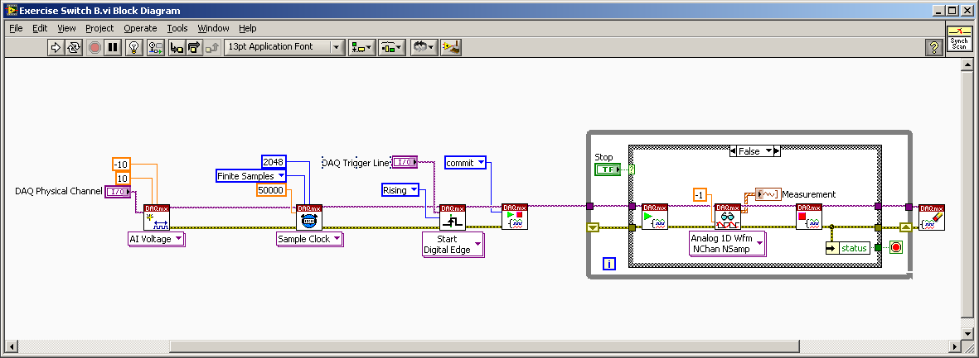

1. In this example we’re going to use the PXI backplane to connect the Digital Trigger button on the DAQ Signal Accessory to the Switch Advance line on the switch. To do this we need to route the Digital Trigger button (PFI0 on the signal accessory) to a TTL line (also called a PXI_Trig line) on the PXI backplane.   
   Place the **DAQmx Connect Terminals VI** (Measurement I/O»NI-DAQmxAdvanced»Signal Routing»Connect) onto the block diagram and create constants for both the **source** and **destination terminals**. Click on the **source terminal** constant and select the PFI0 line on your DAQ card (**/Dev3/PFI0** or **PXI1Slot3/PFI0**). Click on the **destination terminal** and select trigger line 2 on the PXI backplane (**PXI_Trig2** or **PXI1Slot3/PXI_Trig2**). This internally routes the Digital Trigger button (PFI0) through the DAQ card onto TTL2 of the PXI backplane.

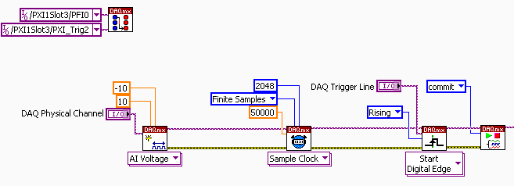

1. Place an **Init w/ Topology VI** (Measurement I/O»NI-SWITCH) onto the block diagram. Connect the **error out** from the DAQmx Connect VI to the **error in** on the Init w/ Topology VI. Right click on the **Resource Name** terminal and create a constant with the device name of your switch (**Dev2** or **PXI1Slot2**).
2. Right click on the Topology Name input and create a constant. Select **2503/2-Wire 24x1 Mux** as the Topology for the DMM/Switch Accessory. This configures the switch to interface correctly with the terminal block connected to it.

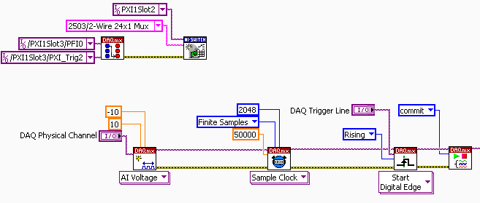

1. Place the **Configure Scan Trigger VI** (NI-SWITCH»Scan»CFG Scan Trig) to the right of the Init w/ Topology VI and connect the **instrument handle** and **error** inputs to the corresponding outputs of the Init w/ Topology VI.
2. Right click on **Trigger Input (External)** and create a constant with a value of **TTL2**. This tells the switch to advance each time a pulse is detected on TTL2 of the PXI backplane (remember that we connected the Digital Trigger button on the DAQ Signal Accessory to TTL2 on the backplane).
3. Right click on **Scan Advanced Output (External)** and create a constant with a value of **TTL0**. This tells the switch to send a pulse on PXI Trigger 0 when the switch has settled after each scan advance. We will use this signal to trigger our DAQ card to acquire samples after the switch has settled.

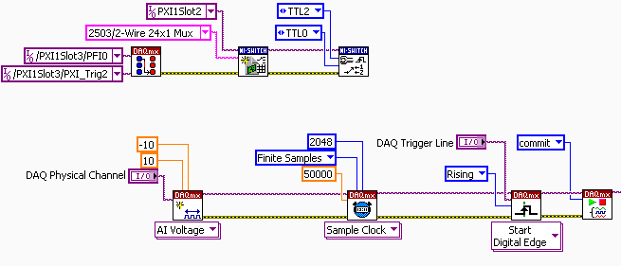

1. Place the **Set Continuous Scan VI** (NI-SWITCH»Set Continuous) to the right of the Configure Scan Trigger VI and connect the **instrument handle** and **error** lines to the corresponding lines of the Configure Scan Trigger VI. Right click on **Continuous Scan** and create a **true constant**. This tells the switch to start over once the end of the scan list is reached so that we can continue to step through the scan list forever.

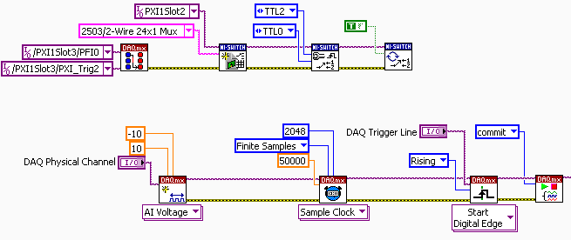

1. Place the **Configure Scan List VI** (NI-SWITCH»Cfg Scan List) to the right of the Set Continuous Scan VI and connect the **instrument handle** and **error** lines to the corresponding lines of the Set Continuous Scan VI. Connect the **error out** line to the **error in** line of the DAQmx Create Channel VI(already present on the block diagram).
2. Right click on the **Scan List** input and create a control. Go to the front panel and enter   
   “*ch1->com0; ch2->com0; ch4->com0; ch5->com0; ch8->com0; ch16->com0; ch18->com0; ch20->com0***;”** into the Scan List control (without quotes). This list tells the switch which channel to connect Com0 to each time the Digital Trigger button is pressed. Switch back to the block diagram.

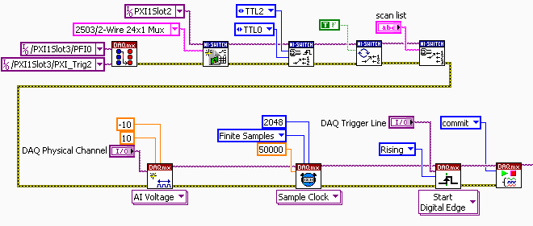

1. Use a wire to connect **analog input 2** of the DAQ Signal Accessory to **COM0+** of the DMM/Switch Accessory. The common terminal in a multiplexed switch topology is the pin that each relay connects its signal to when called in the scan list. In this exercise our terminal block utilize a 2 wire 24x1 multiplexed configuration, which means each time we connect a channel, we are actually connecting two relays, one for the + and one for the – terminal of the channel. This is useful for differential connections. In this exercise we are forced to use the 2 wire multiplexer configuration due to the connector block used. This connector block also supports 4 wire multiplexer configuration, which is why there is an A and B for certain channels. For this reason, we are arbitrarily using the A and + connections on each terminal we connect.
2. Connect the **sine wave** output on the DAQ Signal Accessory to **CH1A+** on the DMM/Switch Accessory. Connect the **square wave** output on the DAQ Signal Accessory to **CH2A+** on the DMM/Switch Accessory. This will allow us to see the variable frequency sine and square waves generated by the DAQ Signal Accessory when our switch reads *ch1->com0;*(sine)or *ch2->com0;*(square).

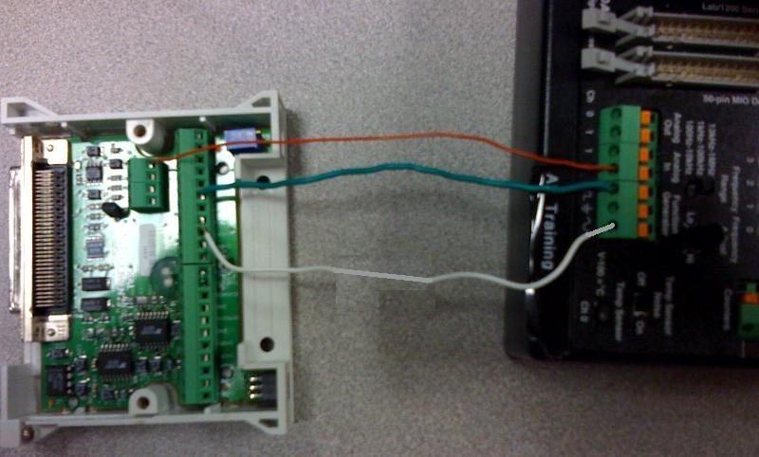

1. Plug the **DMM/Switch Accessory** into the **2503 Switch**. This can be tricky if the wires are too short.
2. Go to the front panel, click on **DAQ Physical Channel**, and select AI2 (**Dev3/ai2** or **PXI1Slot3/ai2**). This tells our DAQ card to sample AI2, which we previously wired to Com0+ on the DMM/Switch Terminal Block.
3. Set the **DAQ Trigger Line** control on the front panel to **Dev3/PXI_Trig0** or **PXI1Slot3/PXI_Trig0**. Look at the block diagram and notice that the DAQmx code is now configured as a hardware-timed, finite acquisition with a retriggerable hardware digital trigger (PXI_Trig0). In this exercise, the DAQ card will acquire 750 samples at 200kS/s each time the Scan Complete line pulses because we are triggering off of PXI_Trig0 (TTL0) on the PXI backplane.

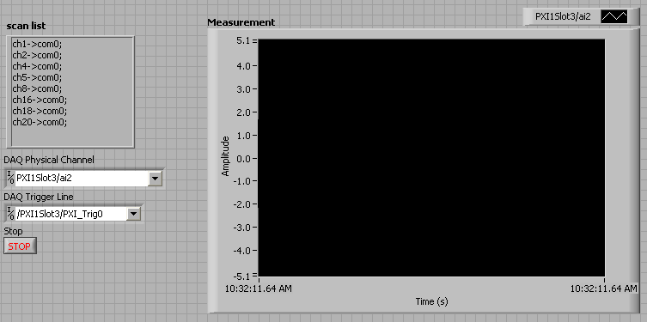

1. Take a moment to breathe and conceptualize what is happening. We are telling the switch to advance to the next configuration in the scan list each time the Digital Trigger button is pressed. To do this, we need to route the Digital Trigger button to the 2503 Switch via the PXI backplane. After settling, the switch sends another signal on the PXI backplane that tells the DAQ card to sample AI2 on the Signal Accessory. Since AI2 is connected to the Common terminal of the switch, each time we sample we will see the currently connected signal.
2. Place the **Initiate Scan VI** (NI-SWITCH»Initiate Scan) to the right of the Configure Scan List VI and connect the **instrument handle** line to the Configure Scan List VI. The Initiate Scan VI downloads the user defined scan list onto the Switch and initiates the scan. Connect the **error out** terminal of the DAQmx Control Task (already present on the block diagram) to the **error input** of the Initiate Scan VI. Connect the error output to the shift register input on the while loop. We run the error line through the DAQmx VIs to set up the analog input task before telling the switch to begin scanning. At this point the switch will advance to the first channel in the scan list and then advance sequentially each time the Digital Trigger on the DAQ Signal Accessory is pressed.

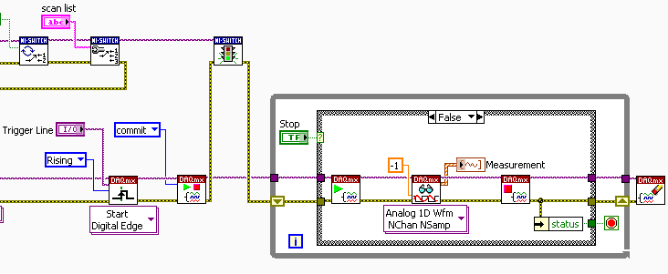

1. Take a look at the code within the while loop. Each time the switch sends a trigger on TTL0, the DAQ card triggers and acquires 750 data points. We must stop and start the task each time to make this acquisition retriggerable.
2. The final step is to clean up the switch configuration after the stop button is pressed. The first thing we need to do is abort the scan by placing the **Abort Scan VI** onto the block diagram above and to the right of the while loop. Connect the **instrument handle** input to the corresponding output of the Initiate Scan VI. Next, place a **Switch Close VI** to the right of the Abort Scan VI and connect the **instrument handle** and **error** terminals. Finally, place a **Simple Error Handler** and connect the error line.

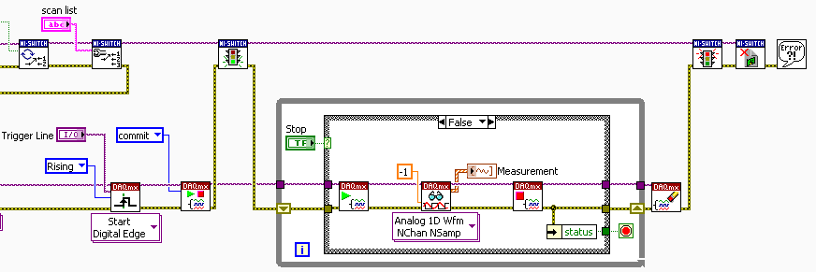

1. Go to the front panel and press the run button. If you listen carefully you can hear the switch scan to its first position. Switch initialization can take several seconds (depending on the switch state), so be patient. Press the Digital Trigger button and listen as each relay energizes. Take a look at the Measurement Indicator on the front panel and notice the different waveforms that are returned. The custom switch terminal block we are using in this exercise generates various waveforms. Make note that with a typical terminal block we would only see relevant signals on channels 1 and 2 (the sine and square waves we physically connected to the terminal block). Here are the waveforms you should sequentially see each time you press the Digital Trigger button:  
   Channel1: Sine Wave (try adjusting the pot on the DAQ Accessory between scans)  
   Channel2: Square Wave (try adjusting the pot on the DAQ Accessory between scans)  
   Channel4: 1Vpp Fixed Sine Wave   
   Channel5: 5Vpp Fixed Square Wave  
   Channel8: -5 Volts  
   Channel16: 0 Volts  
   Channel18: 250 mV  
   Channel20: 5 Volts  
     
   When you’re done scanning through the list, press the stop button. Since the DAQmx read is set to never time out, you will need to press the Digital Trigger button one more time to trigger the read. This can be done programmatically with a parallel loop containing a **DAQmx Control VI** set to **abort**, but this exercise is already difficult enough, so we’ll pass for now.